INSTALLATION GUIDELINES

GLUE-DOWN LUXURY VINYL PLANKS AND TILES

Thank you for choosing our flooring. When properly installed and cared for, your new flooring will be easy to maintain and will keep its great look for years.

Please read all the instructions before you begin the installation. Improper installation will void warranty.

WARNING! DO NOT SAND, DRY SWEEP, DRY SCRAPE, DRILL, SAW, BEAD-BLAST OR MECHANICALLY CHIP OR PULVERIZE EXISTING RESILIENT FLOORING, BACKING, LINING FELT, ASPHALTIC “CUTBACK” ADHESIVES OR OTHER ADHESIVES.
See the current edition of the Resilient Floor Covering Institute (RFCI) publication “Recommended Work Practices for Removal of Resilient Floor Coverings” (US) or the Floor Covering Institute of Australia (FCIA) publication “Best Practice Handbook Volume 1 - Resilient Flooring Installation” (AU & NZ) for detailed information and instructions on removing existing covering structures. For more information go to www.rfci.com (US) or www.fcia.org.au (AU & NZ).

- GENERAL PREPARATIONS

TOOLS REQUIRED: Vacuum/broom, square/straightedge, pencil, tape measure, trowel, chalk line, 75-100 lb. sectional roller, utility knife, safety glasses, kneepads, gloves.

- Prior to installation, inspect material in daylight for visible faults/damage, including defects or discrepancies in color or gloss, check the edges of the flooring for straightness and any damage. No claims on surface defects will be accepted after installation.
- Check if subfloor/site conditions comply with the specifications described in these instructions. If you are not satisfied, do not install, and contact your supplier. Directional designs are optional, however, once the installation is started, you have accepted those conditions.
- Flooring products can be damaged by rough handling before installation. Exercise care when handling and transporting these products. Store, transport and handle the flooring planks in a manner to prevent any damage. Store cartons flat, never on edge.
- Flooring products can be heavy and bulky. Always use proper lifting techniques when handling these products. Whenever possible, make use of material-handling equipment such as dollies or material carts. Never lift more than you can safely handle, get assistance.
- Calculate the room surface prior to installation and plan an extra 5-10% of flooring for cutting waste.
- Do not install flooring over any type of soft substrate, including additional pad type underlayment.

- INDOOR ENVIRONMENT

- The environment where the flooring is to be installed is critically important with regard to successful installation and continued performance of the flooring products. The flooring is intended to be installed in interior locations only. These interior locations must meet climatic and structural requirements as well.
- Flooring should only be installed in temperature-controlled environments. It is necessary to maintain a constant temperature of 65°F- 75°F / 18°C- 23°C before, during and after the installation. Portable heaters are not recommended as they may not heat the room and subfloor sufficiently. Kerosene heaters should never be used.
- After installation, make sure that the flooring is not exposed to temperatures less than 60°F / 15°C or greater than 95°F / 35°C. Excessively high or low temperatures may cause this product to expand or contract and lead to visual defects of the floor that will not be warranted.

- MATERIAL STORAGE AND ACCLIMATION

- Flooring material must be acclimated to the installation area for a minimum of 48 hours prior to installation.
- The permanent HVAC system turned on and set to a minimum of 65°F / 18°C or a maximum of 75°F / 23°C, for a minimum of 7 days prior to and during installation.
- Store cartons of tile or plank products flat and squarely on top of one another. Tile or plank products should be stacked no more than 6 high and allow for air flow around stacks when un‐palletized. Preferably, locate material in the “center” of the installation area (i.e. away from vents, direct sunlight, etc.). Storing cartons in direct sunlight may affect proper acclimation by inducing thermal expansion/contraction.
- When palletizing on a job site vinyl plank or tiles need to be stacked 2 rows high side by side with no airspace between. Then quarter turned for 2 rows side by side, not to exceed 12 boxes high. A 5/8” / 16 mm or thicker plywood must also be placed on the pallet first.
- Please follow the adhesive manufacturer’s guidelines for storing, acclimation or preparation of the glue prior to installation.
- Do not stack pallet’s 2 high unless utilizing a 1” / 25 mm thick plywood in between pallets.

- GENERAL SUBFLOOR INFORMATION

- Inspect subfloor carefully. It must be smooth, clean, dry, structurally sound with no deflection, flat to within 1⁄8” / 3 mm over a 6 ft. / 2 m radius and cannot slope more than 1” / 25 mm over a 6 ft / 2 m span.
- Make sure the subfloor is completely flat. Any joints of more than 1/32” / 1 mm in depth and 3/16” /4 mm in width, depressions, deep grooves, relief cuts (expansion joints must be honored) and other subfloor imperfections must be filled with cementitious patching & leveling compound.
- Any unevenness of more than 1/16” / 2 mm over a length of 3 ft. /1 m must be leveled out. Remove bumps in the subfloor by sanding or scraping. The same applies to unevenness of more than 1/32” / 1 mm over a length of 8” / 20 cm. Use an appropriate leveling compound and check if a primer or sealer is needed with the adhesive supplier.
- Substrates must be free from excessive moisture or alkali. Remove dirt, paint, varnish, wax, oils, solvents, any foreign matter and contaminates.
- Do not use products containing petroleum, solvents or citrus oils to prepare substrates as they will impact bonding strength of glue down installation. Use of adhesive abatement chemicals will void warranty.
- Existing adhesive must be removed complexly and mechanically, use of chemical abatement will void warranty.
- This product is also not to be installed in areas that have a risk of flooding such as saunas or outdoor areas.

- CONCRETE SUBFLOORS

NEW AND EXISTING CONCRETE SUBFLOORS must be structurally sound and in compliance with local building codes.

- Prepare concrete subfloors according to ASTM F710 Standard Practice for Preparation of Concrete Floors to Receive Resilient Flooring. Floors must be fully cured, at least 60 days old, smooth, permanently dry, clean, and free of all foreign material such as dust, wax, solvents, paint, grease, oils, and old adhesive residue. Curing agents and hardeners could cause bonding failure and should not be used. If curing compounds have been used it must be completely removed prior to installation. Consult adhesive manufacturer for recommendations.
- Existing adhesive must be removed complexly and mechanically, use of chemical abatement will void warranty.
- Depressions, deep grooves, control joints and other subfloor imperfections must be filled with appropriate patching & leveling compound. Expansion joints must be respected. Do not fill with patching products or other materials.
- Flooring must not be installed over moving expansion joints.
- Concrete substrates must be flat within 1⁄8” / 3 mm within a 6 ft. / 2 m radius. The substrate should not slope more than 1” / 25 mm over a 6 ft / 2 m span.
- (US) The alkalinity of the slab according to ASTM F710 must not exceed 9.0. Readings below 5.0 and in excess of 9.0 affect resilient flooring and adhesives negatively. Rinsing the surface with clear water may lower alkalinity.
- The concrete moisture vapor emissions should not exceed 8 lbs / 3.63 kg MVER (moisture vapor emission rate) per 1000 ft2 / 100 m2 per 24 hours as measured with the calcium chloride test (ASTM F1869) / 90 % RH (ASTM F2170) with a PH limit of 9 / max. 2.5 % moisture content (CM method / ASTM F2659). Please also refer to ASTM F3010 Standard Practice for Two Component Resin Based Membrane-Forming Moisture Mitigation Systems for Use Under Resilient Flooring Systems.
- Always refer to the adhesive manufacturer’s guideline for acceptable moisture limits.
- (AU) For more information on moisture and alkalinity testing, please follow the Floor Covering Institute of Australia (FCIA) publication “Best Practice Handbook Volume 1 - Resilient Flooring Installation” on www.fcia.org.au.
- Always perform localized bond testing in order to see compatibility of adhesive to the substrate and decide on the proper glue quantity to be used during the installation, as well as to choose the correct trowel size recommended by adhesive manufacturer based on the viscosity of the adhesive. If based on the test result it is still not certain, please contact adhesive supplier/manufacturer for the assistance.
- Note: Indicative glue quantity 225-250sf/g / 4-5 m2/liter.
- Porosity - water drop test will help determine porosity - if drop remains on the surface after 1-2 mins concrete should be considered non‐porous.
- Working and open times of adhesives may vary based on job conditions, substrate, temperature, and humidity.
- Areas to receive flooring should be adequately lighted during all phases of the installation process.

NOTE: IT MAY NOT BE THE FLOOR COVERING INSTALLER’S RESPONSIBILITY TO CONDUCT THESE TESTS. IT IS, HOWEVER, THE FLOOR COVERING INSTALLER’S RESPONSIBILITY TO MAKE SURE THESE TESTS HAVE BEEN CONDUCTED, AND THAT THE RESULTS ARE ACCEPTABLE PRIOR TO INSTALLING THE FLOOR COVERING. WHEN MOISTURE TESTS ARE CONDUCTED, IT INDICATES THE CONDITIONS ONLY AT THE TIME OF THE TEST.
- WOOD SUBFLOORS

Wood subfloors must be structurally sound and in compliance with local building codes.

- If this flooring is intended to be installed over an existing wooden floor, it is recommended to repair any loose boards or squeaks before you begin the installation.
- Ensure the subfloor is free of mold and/or insects.
- The moisture content of the wood must not exceed 10%.
- (AU) Plywood subfloors should comply with the relevant requirements of AS/NZS 2269 and installed in accordance with the requirements for structural sheet flooring given in AS 1684.
- Chip board, OSB, particleboard, construction grade plywood are generally not acceptable substrates – add a layer of approved underlayment grade plywood that is dimensionally stable, non‐staining, with a smooth fully sanded face.
- Double‐Layered APA rated plywood subfloors should be a minimum 1" / 25 mm total thickness, with at least 18" / 45 cm well ventilated air space beneath.
- Insulate and protect crawl spaces with a vapor barrier covering the ground.
- DO NOT install over sleeper construction subfloors or wood subfloors applied directly over concrete.
- Underlayment panels can only correct minor deficiencies in the subfloor while providing a smooth, sound surface on which to adhere the resilient flooring. Offset subfloor panel joints by at least 16” / 30cm so that four corners do not meet.
- Any failures in the performance of the underlayment panel rest solely on the panel manufacturer.
- It is recommended that underlayment grade panels be designed for installation under resilient flooring, and carry a written warranty covering replacement of the entire flooring system.
- This product is not recommended directly over fire-retardant treated plywood or preservative treated plywood. The materials used to treat the plywood may cause problems with adhesive bonding. If in doubt, it is advised to do a local bond test.
- Always follow the underlayment manufacturer’s installation instructions.

- RESILIENT FLOOR COVERING

- Must be single layered, non‐cushion backed, fully adhered, and smooth.
- Must be totally cured and well bonded to the concrete.
- Must be free of any residual solvents and petroleum derivatives. Waxes, polishes, grease, grime, and oil must be removed.
- Show no signs of moisture or alkalinity.
- Grind any highly polished or irregular/smooth surfaces.
- Quarry tile or Ceramic tile grout joints and textured surfaces must be filled with an embossing leveler or substrate manufacturer approved material.
- Do not install over rubber-based substrates.

NOTE: THE RESPONSIBILITY OF DETERMINING IF THE EXISTING FLOORING IS SUITABLE TO BE INSTALLED OVER TOP OF WITH RESILIENT, RESTS SOLELY WITH INSTALLER/FLOORING CONTRACTOR ON SITE. IF THERE IS ANY DOUBT AS TO SUITABILITY, THE EXISTING FLOORING SHOULD BE REMOVED, OR AN ACCEPTABLE UNDERLAYMENT INSTALLED OVER IT. INSTALLATIONS OVER EXISTING RESILIENT FLOORING MAY BE MORE SUSCEPTIBLE TO INDENTATION.

- Quarry Tile, Terrazzo, Ceramic Tile, Poured Floors (Epoxy, Polymeric, Seamless)

- Must be totally cured and well bonded to the concrete.
- Must be free of any residual solvents and petroleum derivatives. Waxes, polishes, grease, grime, and oil must be removed.
- Show no signs of moisture or alkalinity.
- Cuts, cracks, gouges, dents, and other irregularities in the existing floor covering must be repaired or replaced.
- Fill any low spots, holes, chips and seams that may telegraph through the new flooring.
- Grind any highly polished or irregular/smooth surfaces.
- Quarry tile or Ceramic tile grout joints and textured surfaces must be filled with an embossing leveler or substrate manufacturer approved material.
- Always perform bond testing.
- SUBFLOOR HEATING

Due to the speed of sudden temperature changes, which has the potential to negatively affect this flooring, it is not recommended to install over any electrical radiant heating system. Installation over electrical radiant heating systems will not be covered by the manufacturer’s warranty. Below instructions are for EMBEDDED radiant heating systems using water.

- In-floor water based Radiant Heat: Flooring can be installed over 1/2" / 12 mm embedded radiant heat.
- Maximum operating temperature should never exceed 80°F / 27°C. Use of an in-floor temperature sensor is recommended to avoid overheating.
- Turn the heat off for 24 hours before, during and 24 hours after installation when installing over radiant heated subfloors.
- Before installing over newly constructed radiant heat systems, operate the system at maximum capacity to force any residual moisture from the cementitious topping of the radiant heat system.
- Make sure that the temperature in the room is maintained consistent between 65°F- 75°F / 18°C- 23°C before and during the installation.
- Once the installation is completed, the heating system should be turned on, at the ambient temperature and increased gradually 9 °F / 5 °C degree increments every 12 hours until reaching normal operating conditions.
- WARNING: Electric heating mats that are not embedded into the subfloor are not recommended for use underneath the floors. Using electric heating mats that are not embedded and applied directly underneath the floors could void the warranty for your floor in case of failure. It is best to install the flooring over embedded radiant floor heating systems and adhere to the guidelines listed above.
- Refer to the radiant heat system’s manufacturer recommendations for additional guidance.
- Tip: The best idea to maximize the results of your heating system is to have “ON” times with a comfort temperature and “OFF” times with setback temperatures which is normally 8°F / 4°c lower than your comfort temperature. The setback temperatures are particularly important as these won’t let the temperature of your room drop too much, meaning it is much quicker to heat your room back to comfort levels when it’s needed.

- LAYOUT AND INSTALLATION

- GENERAL RULES

- It is customary to center rooms and hallways, so borders are not less than half a tile or plank.
- It is preferable to lay boards following the direction of the main source of light. For the best result, make sure to always work from 3 to 4 cartons at a time, mixing the planks during the installation.
- In hallways and small spaces, it may be simpler to work lengthwise from one end using a center reference line as a guide.
- Make sure cut edges are always against the wall.

- ADHESIVE

IMPORTANT: for optimal adhesion A waterproof, hard-setting acrylic adhesive is recommended for residential application and A TWO-PART POLYURETHANE OR EPOXY ADHESIVE for commercial applicationS. ALWAYS perform adhesion testing to determine the compatibility of the adhesive to the substrate, if insufficient, a primer can be utilized to improve adhesion.

- Protect the adhesive from dirt and debris.
- Working and open times of adhesives may vary based on job conditions, substrate, temperature and humidity.
- Bond testing should always be performed to verify the compatibility of adhesive to the substrate.
- Note: Indicative glue quantity 225-250sf/g / 4-5 m2/liter.
- Always use a new trowel to ensure an even and correct distribution of vinyl glue over the subfloor.
- Apply the adhesive on the floor for about the same width as the two first rows. Always take into account the instructions of the adhesive.
- Place the planks into the adhesive, adjust the correct position and push or roll down to ensure good adhesive transfer to the back of the planks.
- All glue residue should immediately be removed with a damp cloth. Never use detergents.
- Use the same procedure to complete the rest of the room.
- To ensure the best bonding, adhesive transfer and that no air is trapped between the subfloor and the installed floor, immediately after the installation roll each installed section of flooring in both directions with a 75-100 lb. sectional roller for the first turn. Wait no longer than 30 minutes before rolling on the installed area.

- LAYOUT OF THE ROOM
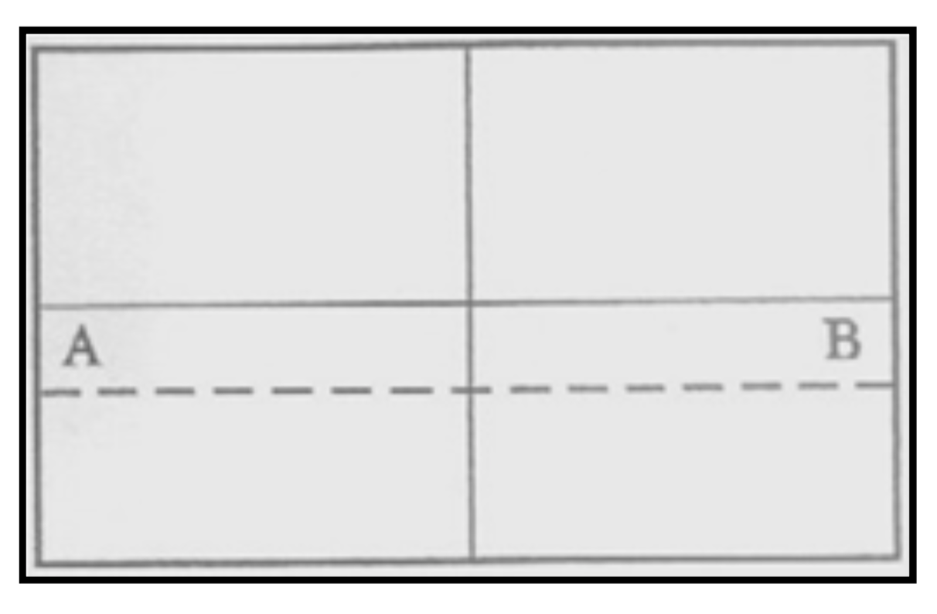
- Find the center point of the room. Strike a line.
- Obtain a true 90 º angle by using a 3-4-5 method.
- Strike a second line which will divide the room into four equal parts.
- Measure the distance from the center to the wall, parallel to the direction of the plank.
- Divide the measurement by the width of the plank. If less than half remains as the border plank, adjust the point to compensate. This will give a larger border along the wall and reduce the chance of having to cut a small sliver of flooring to place along the wall.

- FLOORING LAYOUT
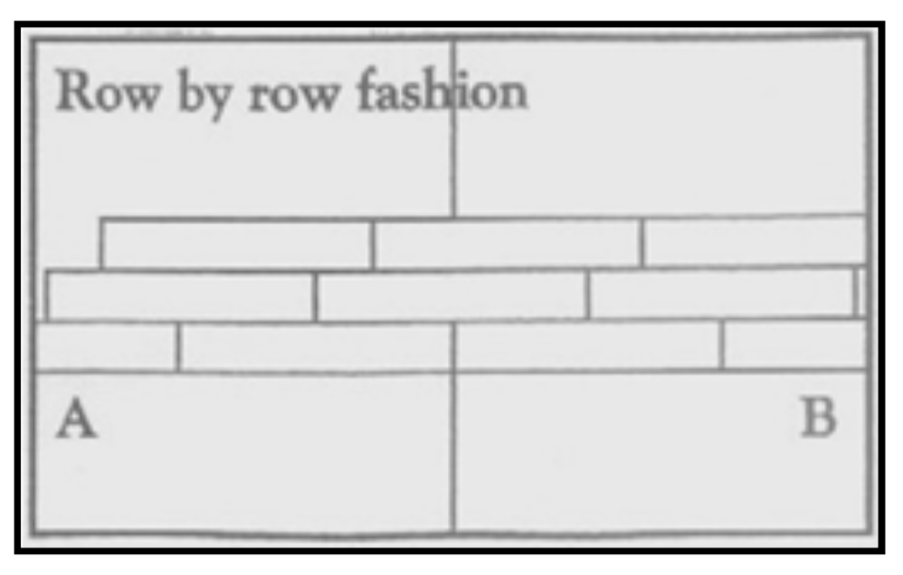
- We recommend dry fitting first (without glue). Start the first row with a whole plank in length.
- Carefully place the first piece of plank at the junction of the chalk lines.
- Continue to lay the plank, making sure each plank flush against the chalk line and tight against the adjoining plank.
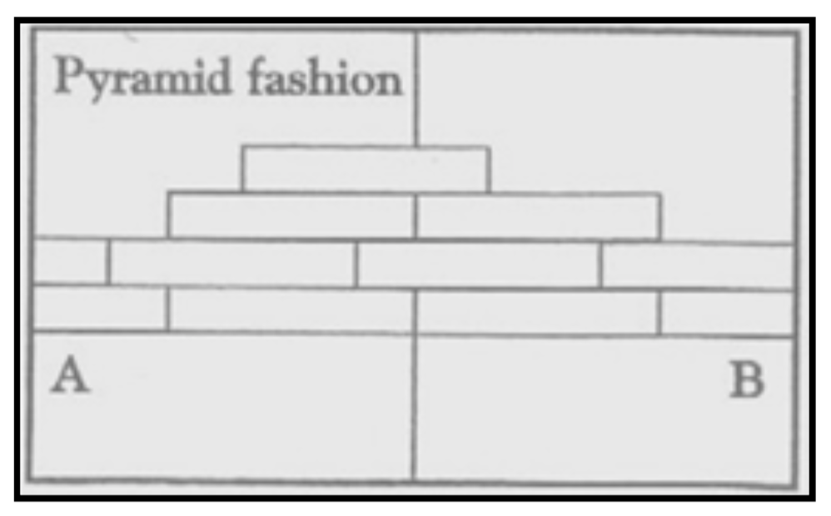
- Make sure the plank is well seated into the adhesive paying special attention, to the edges.
- Lay row by row, or in a pyramid fashion (see below).
- It is strongly recommended to stagger the rows by at least 12” / 30 cm so that the short edge seams are not in a straight uniform line. However, you may want to try other patterns of planks to suit your taste.
- Make sure the first rows are on a perfect straight line. For instance, it is possible that your starting wall has a slight angle. You can check this by holding a thin rope and adjust the straightness of your floor where necessary. Before placing the planks in the glue, please make sure you have cut them to the right size, planks can be cut net to vertical obstructions, but cannot be force fit.

- BOARDERS

- Measure the distance from the last plank in the row to the wall.
- Mark the plank and cut it against the mark.
- Lay the plank in place, making sure that the cut edge is against the wall.

- FITTING AROUND IRREGULAR OBJECTS

- Make a pattern out of heavy paper to fit around pipes and other irregularities.
- Place the pattern on the plank, trace cutting along the trace lines.

- CUTTING

- To make cuts simply measure and mark the plank. Score and snap using a sharp utility knife. Use proper PPE when using knives.

- FINISHING THE INSTALLATION

- Sweep up scrap material and any loose debris.
- Clean any wet adhesive from the surface of the flooring material with a clean white cloth dampened with water. Dried adhesive will require the use of denatured alcohol and a clean white rag. Never pour solvent directly on floor. Follow manufactures label precautions when using denatured alcohol.
- 20 minutes after first rolling floor, roll again in perpendicular direction using a 75-100 lb. roller.
- The glue must be able to cure 100% before moving in furniture. Hence, leave the floor untouched for 72 hours after installation between 65°F / 18°C and 75°F / 23°C for the curing process to complete.
- For rooms with a high moisture level like bathrooms, a waterproof transparent silicone must be used around the perimeter.
- Replace molding or wall base, allowing slight clearance between the molding and the planks.
- Nail the molding to the wall surface, not through the flooring.
- At doorways and at other areas where the flooring planks may meet other flooring surfaces, it is preferable to use a “T” molding, or similar, to cover the exposed edge.
- Leave a small gap between the planks and the adjoining surface.

- MAINTENANCE

- Sweep or vacuum daily using soft bristle attachments. Do not use vacuum equipped with beater bar.
- Do not buff or sand the surface.
- Clean up spills and excessive liquids immediately.
- Damp mop as needed and use neutral cleaners recommended for vinyl flooring.
- The use of residential steam mops on this product is allowed. Use at lowest power with a suitable soft pad, and do not hold a steam mop on one spot for an extended period of time (longer than 5 minutes). Refer to the steam mop's manufacturer instructions for proper usage.
- Use proper floor protection devices such as felt protectors under furniture. Equip wheeled-type office chairs and other rolling furniture with wide-surface, casters at least 2” / 5 cm in diameter.
- Place a walk-off mat at outside entrances to reduce the amount of dirt brought into your home. Do not use mats with a latex or rubber backing since these backings can cause permanent discoloration.
- Do not use abrasive cleaners, bleach or wax to maintain the floor.
- For stubborn spills use low odor mineral spirits or denatured alcohol applied to a clean cloth. Never pour chemicals directly on floor.
- Do not drag or slide heavy objects across the floor.

